After-Prom 2023 Logo Design Contest
The contest winner’s logo will be used to promote After-Prom 2023 on marketing and publicity materials, t-shirts, signage, and related correspondence.
After-Prom is an exciting night of fun for all juniors and seniors whether or not they attend the prom dance. After-Prom will be held at the YMCA on Saturday, April 29, 2023 from 11:00pm-3:00am Sunday, April 30th. The event includes inflatables, a casino room, dodgeball tournament, rock climbing wall, caricature artists, henna tattoos, gift card giveaways, major raffle prizes, coffee lounge, tons of free food from Qdoba, Chick-fil-A, Rita’s, Starbucks, Vocelli’s, and so much more.
A logo is a “graphic representation or symbol of a company name, trademark, abbreviation, etc., often uniquely designed for ready recognition.” Logos can be comprised of an illustration, just text, or any combination thereof. Some well-known examples include past contest winners & more:
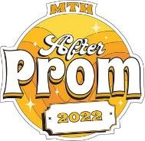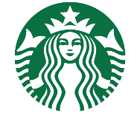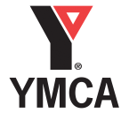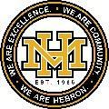
Prizes for the winning logo design:
* $25 gift card to Amazon
* 2 Free Tickets to After-Prom (if winner is a junior or senior)
* Winner will be named on morning announcements

Logo Design Specifications/Contest Guidelines
- A student may submit as many designs as he/she/they like. Designs should include “2023” and reference to Mt. Hebron, MTH, MHHS, Hebron, etc. and “After Prom”
- The design must be submitted in a jpg or png digital format. No hand drawn images.
- The design will primaroy be used on letterhead, social media and T-shits so it should legibly scale at multiple sizes. The smallest size to scale to reduce to is 1 ½” x 1 ½” and the largest could vary base on T-shirt size but think 6x8.
- The design must be wholly original. By submitting a design you are guaranteeing that you hold rights to everything in it and that it does not contain any copyrighted material.
- Entries may be submitted in black and white or color. If submitted in color, they should also be reproduceable in black and white.
- Entries must be emailed to Heather Hogan at mthafterpromlogo@gmail.com by midnight January 31, 2023.
- All entry emails should have the subject line “After-Prom Logo Design Contest”.
- Include artist’s name, grade, email address and third period teacher.
- Entries become property of the Mt. Hebron PTSA. We reserve the right to make adjustments to the winning design. The winner will be announced by February 8, 2023.
- By submitting you are agreeing to all contest rules.
Questions? Contact Heather Hogan and After-Prom Committee Logo Chair, at mthafterpromlogo@gmail.com .

