Mt. Hebron PTSA Scholarship
Application Form

Mt. Hebron PTSA is pleased to offer seven (7) $1,000 scholarships to seven (7) graduating seniors. These scholarships are intended to support a student in their future endeavors, which may or may not be higher education. These scholarships will be paid out in two installments. Checks made out to the student will be distributed as follows: $500 in May at the awards assembly, and $500 by mail the following January. To be eligible, a student and at least one parent must be current members of the PTSA prior to March 31, 2023.
Application submissions are due by April 15, 2023, NO LATER THAN 2 PM, and are to be scanned and emailed to scholarships@mthebronptsa.com. If you have trouble being able to scan and email, please contact Laura Munns, Scholarship Chair, at above email address. Only complete applications will be considered. Late applications will not be considered. A complete application submission includes:

- This application form signed by the applying student and the parent PTSA member.
- Typed response (no greater than 300 words) to one of the below Essay questions.
- Extra-Curricular Activities forms.

Applicant Information:

Name: ___________________________________________________________

**Home Street Address:__________________________________

Telephone:_____________

Student Email Address: ___________________________________________________________

Parent/Guardian Information who is a current PTSA Member:

Parent/Guardian Name:_________

Parent/Guardian Email:_____________________________________________________

Please tell us your plans for next year. Are you planning on going on an adventure, pursuing your education, going directly into the work force?

**The second check for recipients will be mailed to the home address, so it is vital that this address be a location you can be reached in January 2024.

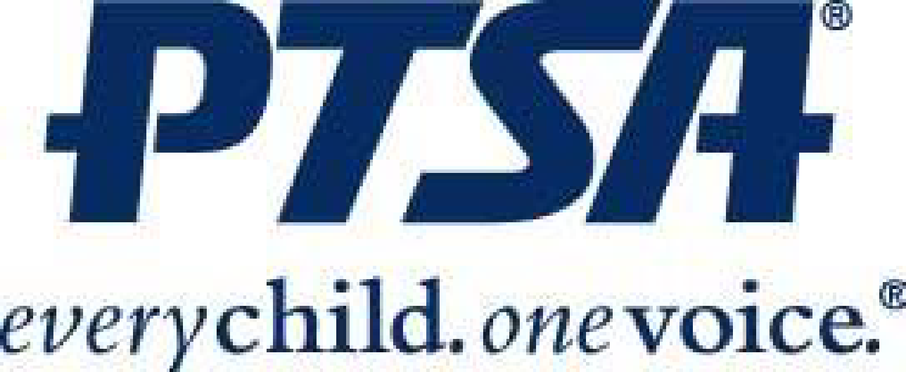
Mt. Hebron PTSA Scholarship
Application Form

ESSAY QUESTIONS: Pick ONE of the questions below to answer on a separate page. Please try not to send as a pdf, but instead as a word or pages document. Responses must not exceed 300 words. May be typed or handwritten and scanned

- What has been your most difficult challenge during your high school years; how have you successfully dealt with this challenge?

- PTSA is an organization based on advocacy for those in our school community. Tell us about a time you advocated for someone in Mt. Hebron’s school community.

- If you could teach your peers one thing, what would it be? Why?

- What does the PTSA mean to you and why should students join?

***************************************************************************
My parent and I are current members of the Mt. Hebron PTSA.

Student Name:_________ ______

Student Signature:

Parent/Guardian Name:__________

Parent/Guardian Signature:

Date:___

Submit your signed Application form, essay question response, and Extra Circular Activities forms, to the PTSA Scholarship Chair no later than 2 PM on April 15, 2023. Email to: scholarships@mthebronptsa.com

Mt. Hebron PTSA Scholarship
Application Form

In School Activities

Please list in school activities including honor societies, teams, clubs, etc.. List the grade that you participated in the activity (if more than one year, list each year). Make sure to include any leadership positions. Use additional pages as necessary.

Grade and/or Year | Type of Activity: Sports/Clubs | Description of Activity

Mt. Hebron PTSA Scholarship
Application Form

Community Activities/Employment
Please list things you do OUTSIDE of school – Community activities, community service, and any work experience (paid or unpaid). Include any awards, special projects, etc. List the grade that you participated in the activity (if more than one year, list each year). Use additional pages as necessary.

Grade and/or Year | Type of Activity:  Community Service or Work Experience | Description of Activity

